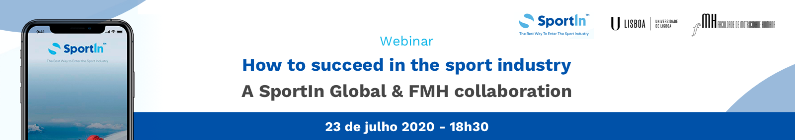

Programa

Sessão de Abertura
Ana Naia, Vice-Presidente da FMH

The Labour Market today and how to tackle the opportunities
Ricardo Carvalho, FMH Alumni 1988-1993.

The link between the student, FMH and the Job Market
Rui Durão, Presidente do Núcleo Gestão do Desporto FMH

The experience as a Director at 2016 RIO Olympic and Paralympic Games
Luís Ryff, Board Advisor of SportIn Global

SportIn Summit & internship position
Eduardo Drapier, SportIn Global

